**IEEE Student Chapter, Thapar University**

**IEEE Student Chapter Annual Report 2016**

1. IEEE Workshop on Big Data

Venue: UG-CS lab, Thapar University

On Feb 8th 2016, there was a workshop on Big Data organised in Thapar campus. Fifty Six students of Computer Science branch attended the complete workshop which included Hadoop configuration, as well as working on Cloudera.

The Workshop started around 10 a.m. in the morning. It was conducted by APTRON. Experts from APTRON focussed on the scope of Big Data with a lot concentration on Hadoop. Some of the topics discussed by them were:

* Big Data Analytics.
* Business Intelligence.
* Hadoop

This workshop also focussed on current industry standards that may help attendees to secure placements for their dream jobs in MNCs. Workshop ended around 5:30 pm .

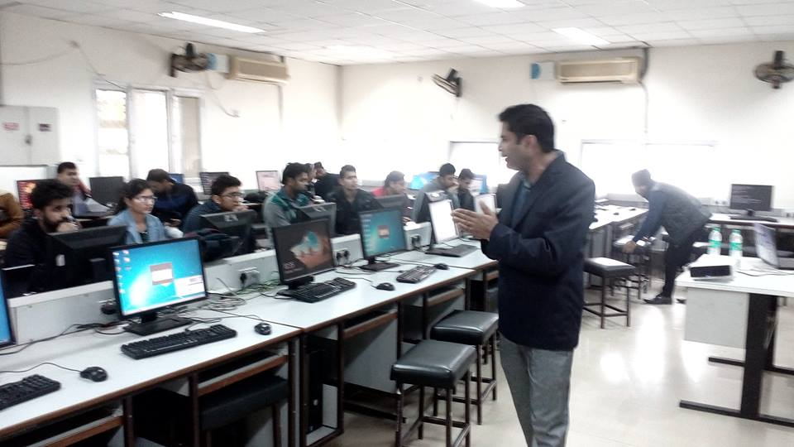

1. IEEE Student Chapter Quiz organised for teachers.

Place: E Block, Thapar University

On April 28th 2016, IEEE Student Chapter organised a situation based quiz for teachers. This quiz focussed on the situations that teachers had to deal somehow at a time while teaching or examining a student’ data.

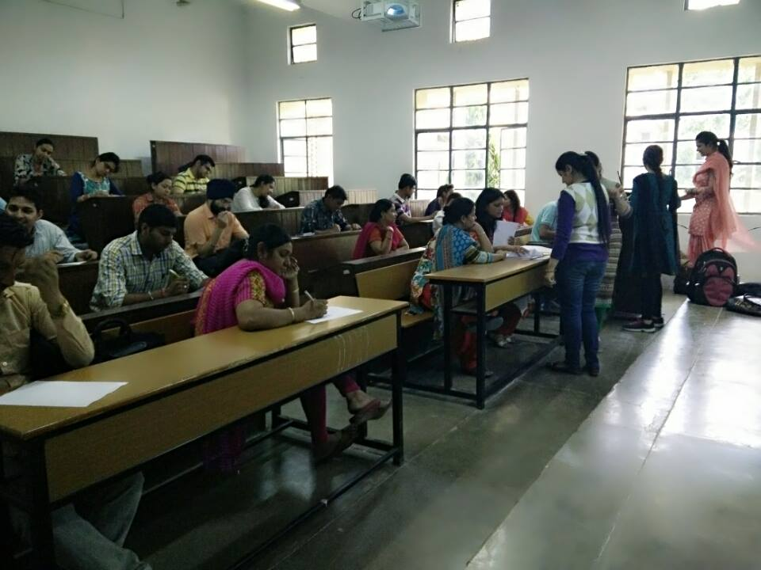

1. IEEE Student Chapter organised Lan Gaming

Place : Hostel J Thapar University

On May 14th 2016,IEEE student Chapter organised LAN Gaming which lasted for 2 days. This was actually an Intra-hostel competition for boys. Interested students participated in this competition. Teams were made and winning team was rewarded by the amount of Rs 2000.

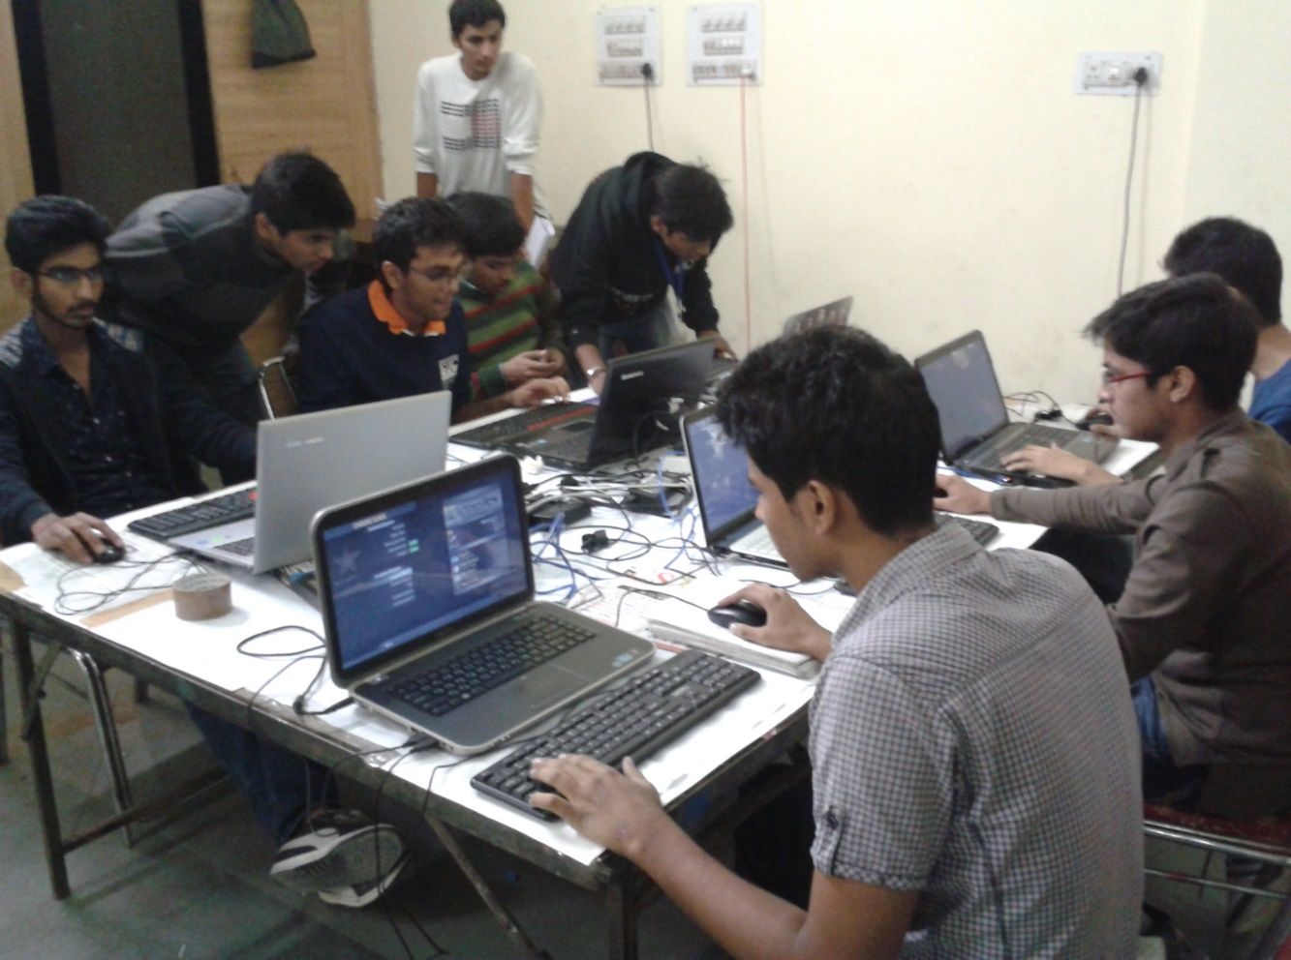

1. IEEE Student Chapter Research Paper Workshop

Place : F Bock, Thapar University

This workshop was organized for teachers in order to convey an idea how to write an effective research paper.In the end, tasks were given to the students who attended this workshop for writing a sample research paper and also they were given certificates for the same.

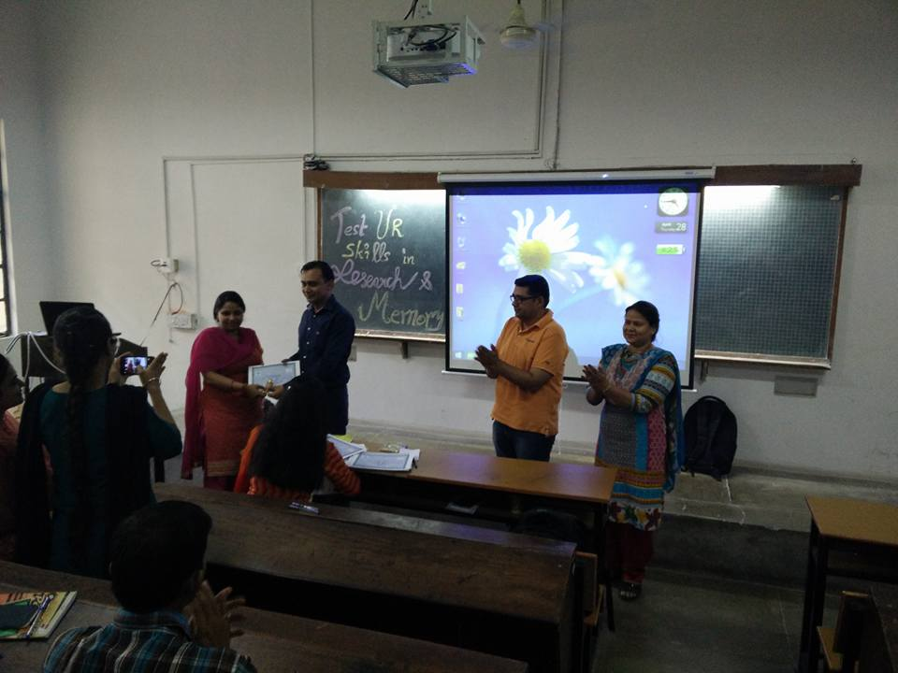

1. IEEE Student Chapter organised workshop on Ethical Hacking

Place: TAN Audi, Thapar University

Speaker- Mr. Rishabh Arora, Fidelity, India

On April 22nd2016, there was a workshop on Ethical Hacking by Mr. Rishabh Arora for computer science students. He laid our attention towards aspects such as SQL Injection, Phishing, Web Attacks , Cyber Security etc. Our respective HOD Dr. Maninder Singh who is an expert in Ethical Hacking concluded on new horizons in Cyber Security.

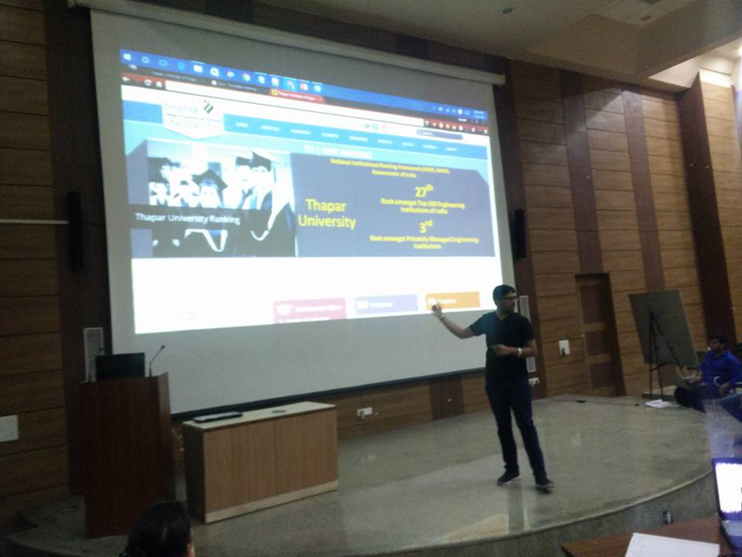

1. IEEE Student Chapter organised workshop on Applications on Map Reduce

Place: TAN Audi, Thapar University

Speaker: Mr. PulkitKhurana

(Software Engineer at Google)

On September 14th 2016,there was a workshop hosted by Mr. Pulkit Khurana based on applications of Map Reduce. Topics discussed were:

* Hadoop Streaming
* Components of MapReduce
* HDFS Operations

Workshop started around 10am in the morning and lasted till 4pm in the evening.

He gave a brief idea about how this Map-Reduce has lessen the loads of the companies

And how even google itself is utilizing this amazing concept.

